Question 1 3 pts
Let B = {2, 3, 4} and C = {2}. Is it true that C&Element;B
True
False

Flag this Question
Question 2 3 pts
Let A={1,2}. Is it true that element ?
True
False

Flag this Question
Question 3 3 pts
Let A={a, b, {c, d, e}, {b, d}}. What is the cardinality of A?
HTML Editor Keyboard Shortcuts
p

Flag this Question
Question 4 3 pts
Which of the following is the power set of set {a, b}?
{{a}, {b}}
{{}, {a}, {b}, {a, b}}

{{a}, {b}, {a, b}, {b, a}}
{{a, b}}

None of the above

Flag this Question
Question 5 3 pts
Let A = {3, 4, 6, 8, 9}, B = {2, 5, 7, 9}, and C = {4, 7}. What is
{4}
{4, 7}

{2, 3, 4, 5, 6, 7, 8, 9}
{4, 7, 9}

none of the above

Flag this Question
Question 6 3 pts
Which of the following can represent the shaded part of the Venn Diagram?
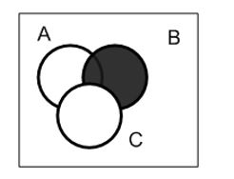

none of the above

Flag this Question
Question 7 3 pts
True or False. is a set identity.
True
False

Flag this Question
Question 8 3 pts
Given the set B = { 1, 2, 3 }, is it true that (3, 3, 3) ∈ B³?
True
False

